Software Requirement Specifications

Student Portal System Ashishkumar Bhedi (22bce024)
Table of Contents
1. Introduction 1
1.1 purpose
1.2 scope
1.3 overview
2. Overall Description 2
2.1 Product Perspective
2.2 Product functionalities
2.3 User Characteristics:
2.4 Assumptions and Dependencies
3. External Interface Requirements
3.1 User Interface
3.2 Hardware Interfaces
3.3 Software Interfaces
3.4 Communications Interfaces
4. functional requirements 4

4.1 student requirement
4.2 faculty requirement
4.3 administer requirement
5. Nonfunctional Requirements 4
5.1 Performance Requirements
5.2 Security Requirements
5.3Availability and Reliability
5.4 Usability
5.6 Compatibility
5.7 Data Synchronization
5.8 Computer Resource Requirements
6. system models 5

Revision History
Name | Date | Reason For Changes | Version

Introduction

Purpose
The purpose of this document is to describe the functional and non- functional requirements of the student portal system. This SRS document serve as a reference for the requirements of the project and This document clearly defines what system will do and how should perform without describing the implantation details.

SCOPE
The Scope of the project to improve the communication and academic management within as education institute.
The system provides the features:
- Student and faculty login and profile management
- Sharing academic information like assignments, notices, and results
- Faculty management of courses, attendance, and assessments
- Secure communication between students and faculty
- Centralized academic data management
OVERVIEW
The proposed system is designed to provide an efficient and user-friendly solution for managing and monitoring the complete workflow of the project. It integrates planning, execution, tracking, and reporting into a single platform, allowing users to visualize progress through timelines and milestone markers. The system helps in organizing tasks, tracking deadlines, and ensuring timely completion of activities. By simplifying coordination and progress monitoring, the system improves productivity, reduces manual effort, and supports better decision-making throughout the project lifecycle.

Overall Description

Product Perspective:
The Student–Faculty Portal System is a standalone web application that can be integrated with existing institutional systems such as learning management systems or databases if required.

Product functionalities:
Major functionalities of the system include:
- User registration and authentication
- Role-based access (Student, Faculty, Administrator)
- Course and subject management
- Assignment creation and submission
- Attendance management
- Academic notifications and announcements
- Secure messaging between students and faculty
- Report generation and data viewing

User Characteristics:
- Primary Users: Farmers with basic smartphone or web navigation skills.
- Secondary Users: Agricultural consultants and researchers requiring detailed insights.
Constraints:

Requires stable internet connection

Must comply with institutional data privacy policies

Limited development resources (single developer)

Must work efficiently on standard browsers

Assumptions and Dependencies:
- Users have access to smartphones or computers
- Institution provides necessary academic data
- Email services are available for notifications
- Hosting server is reliable and secure

External Interface Requirements

User Interfaces
- Logical Characteristics:
The user interface (UI) is designed to be simple, intuitive, and user-friendly, enabling users with basic technical knowledge to operate the system efficiently. The interface supports both web and desktop access, ensuring ease of use across different devices. The design focuses on clarity, minimalism, and quick access to essential features.
  - Screen Layout Constraints:
    - Clean, simple layout with large buttons and readable fonts.
    - Readable fonts and consistent color theme of for the better visibility.
    - Important features like assignment timeline, milestones and task status should be easily accessible in the main screen .
    - Use standard navigation bars, icons, and help buttons.
  - Standard Buttons & Functions:
    - Help: A floating help icon visible on every screen.
    - Navigation: Clear "Back" and "Home" buttons to easily move between sections.
    - Notifications: Alerts for upcoming deadlines, message notification, or delay of the assignment should displayed.
    - Input Fields: Consistent input fields for data entry .
  - Screen Examples:
    - Home screen: Displays a personalized dashboard showing student profile details, enrolled courses, attendance summary, recent announcements, and quick links to important features..
    - Displays a personalized dashboard showing student profile details, enrolled courses, attendance summary, recent announcements, and quick links to important features.
    - Course & Materials Screen:
Allows students to view registered courses, access study materials, assignments, and important academic resources..
  - Error Messages:
    - Informative messages for system errors or data entry issues (e.g., "Unable to fetch data, please check your connection").
    - Provide recommendations for troubleshooting where necessary.
  - Keyboard Shortcuts:
  - Include a visual guide for mobile users with swipe gestures for easier navigation.

Hardware Interfaces
- Device Types:
The Student Portal System will interface with commonly used digital devices to allow students, faculty, and administrators to access academic and administrative services efficiently.
  - Supported Devices:
    - Smartphones/Tablets: Android and iOS devices.
    - Server Systems: Centralized application and database servers to store, process, and manage student records, academic data, and user information.
  - Data & Control Interactions:
    - Student and faculty data (such as attendance, marks, course details, and announcements) will be stored and retrieved from the central database through secure APIs.
    - Faculty members can upload marks, attendance, assignments, and notices, while students can view and download academic information.
    - Administrators can manage users, courses, schedules, and system configurations through control functionalities provided by the portal.
  - Communication Protocols:
    - HTTP/HTTPS: For secure communication between mobile/web apps and the cloud server.
    - Wi-Fi / Internet Connectivity: Required for users to access the system from campuses, homes, or remote locations.

Software Interfaces
- Connections Between Software Components:
The software will interface with several software tools and libraries for processing and visualizing data:
  - Database: A MySQL database to store student records, faculty details, course information, attendance, marks, messages, and system logs.
  - Operating System:
    - Web version: Compatible with popular browsers (e.g., Chrome, Firefox, Edge).
    - Mobile version: Android (API level 21 and up) and iOS (version 12 and up).
- Backend Frameworks & Tools:
Backend Framework: Flask (Python) for handling business logic, authentication, and API services.
API Layer: RESTful APIs for communication between frontend and backend modules.
- Frontend Technologies:
HTML, CSS, JavaScript for building responsive user interfaces.
UI Libraries: Bootstrap or Tailwind CSS for consistent layout and styling.
- Data Visualization Libraries:
Chart.js or similar libraries for visualizing academic performance, attendance trends, and progress reports.
- External Software & Services:
Email Services: Integration with SMTP or third-party email services for notifications, password recovery, and announcements.
Messaging Services: Internal messaging module to enable communication between students, faculty, and administrators.
Authentication Services: Secure login and role-based access control for students, faculty, and administrators.
- File Handling & Storage:
Support for uploading and downloading academic documents such as assignments, notices, and reports.
Files may be stored on the server or cloud-based storage if required.

Communications Interfaces

- Real-Time Messaging: The system should send real-time notifications to users for important academic and administrative updates such as exam schedules, assignment deadlines, attendance alerts, and important announcements from faculty or administration.
- Data Syncing: The system must support real-time synchronization of academic data (marks, attendance, course materials, notices) between the server and user interfaces to ensure that students and faculty always access updated information
- .Email/Push Notifications:
  - Email: For system updates, reminders about scheduled irrigation, or pest control alerts.
- Push Notifications: Used for immediate alerts such as upcoming deadlines, class cancellations, newly uploaded assignments, or changes in schedules.Message Formatting:
Short and clear messages (e.g., “Assignment submission deadline is tomorrow” or “New marks have been uploaded for Database Systems”).
4. Functional Requirements
4.1 Student Requirements
4.1.1 Login
4.1.1.1
To log in to the system, the following details are required:
- 4.1.1.1.1 Email Address – Must be a valid registered or institutional email address
- 4.1.1.1.2 Password – Must contain at least 8 characters and be entered in password-protected mode

4.1.2 Create Account
4.1.2.1
Students can register themselves on the Student Activity & Placement Portal.
4.1.2.2
For registration, the following details are required:
- 4.1.2.2.1 Email Address – Must be a valid email address
- 4.1.2.2.2 Password – Minimum 8 characters
- 4.1.2.2.3 Student Details:
  - 4.1.2.2.3.1 Full Name
  - 4.1.2.2.3.2 Student ID / Roll Number
  - 4.1.2.2.3.3 Course / Program
  - 4.1.2.2.3.4 Year / Semester
  - 4.1.2.2.3.5 Department
  - 4.1.2.2.3.6 Mobile Number
  - 4.1.2.2.3.7 Address
Upon successful registration, all details will be stored in the database.

4.1.3 Manage Profile
4.1.3.1
Students can update their personal and academic profile details.
4.1.3.2
Student ID and registered email address cannot be modified.
4.1.3.3
All updated information will be saved after successful validation.

4.1.4 Placement Information
4.1.4.1
Students can update their placement status (Placed / Not Placed).
4.1.4.2
Placed students can provide:
- Company name
- Job role
- Package details
- Placement year
4.1.4.3
Students can view their placement history and current placement status.

4.1.5 Higher Studies (Masters) Information
4.1.5.1
Students can indicate whether they are planning to pursue higher studies.
4.1.5.2
Students pursuing or planning Masters can enter:
- University name
- Country
- Course name
- Admission status
4.1.5.3
Students can update or modify higher studies information at any time.

4.1.6 Curricular Activities
4.1.6.1
Students can view their curricular activities such as:
- Projects
- Internships
- Workshops
- Certifications
4.1.6.2
Students can add or update curricular activity details.

4.1.7 Extracurricular Activities
4.1.7.1
Students can add and manage extracurricular activities including:
- Sports
- Cultural events
- Technical clubs
- Volunteering activities
4.1.7.2
Students can upload participation details and achievements.

4.1.8 Committee Participation
4.1.8.1
Students can view available committees in the institution.
4.1.8.2
Students can update their committee membership details.
4.1.8.3
The system will maintain records of:
- Committee name
- Role (Member / Coordinator / Lead)
- Duration

4.1.9 Messaging & Communication
4.1.9.1
Students can send messages to faculty members and administrators.
4.1.9.2
Students can receive messages, announcements, and notifications.
4.1.9.3
The system supports one-to-one and group messaging.

4.1.10 Notifications
4.1.10.1
Students will receive notifications related to:
- Placement updates
- Committee announcements
- Activity approvals
- Important institutional messages

4.1.11 Forgot / Change Password
4.1.11.1
Students can reset their password using the registered email address.
4.1.11.2
Students can change their password after logging in.

4.2 Faculty Requirements
4.2.1 Faculty Login
Faculty members must log in using registered credentials.

4.2.2 Manage Profile
Faculty can update personal and professional information except faculty ID.

4.2.3 Student Activity Monitoring
4.2.3.1
Faculty can view student participation in curricular and extracurricular activities.
4.2.3.2
Faculty can verify or approve activity records if required.

4.2.4 Placement & Higher Studies Monitoring
4.2.4.1
Faculty can view placement statistics of students.
4.2.4.2
Faculty can view students opting for higher studies.

4.2.5 Messaging & Communication
4.2.5.1
Faculty can send messages to individual students or groups.
4.2.5.2
Faculty advisors can communicate with assigned students.

4.2.6 Notifications & Announcements
Faculty can post announcements related to activities, committees, or placements.

4.3 Administrator Requirements
4.3.1 User Management
Administrator can:
- View student and faculty details
- Activate or deactivate accounts
- Delete accounts if required

4.3.2 Activity & Committee Management
Administrator can manage:
- Curricular activities
- Extracurricular activities
- Institutional committees

4.3.3 Placement & Higher Studies Management
Administrator can:
- View placement statistics
- Track students pursuing higher studies
- Generate summary reports

4.3.4 Messaging & Communication Control
Administrator can monitor announcements and communication logs for security.

4.3.5 Report Generation
Administrator can generate reports related to:
- Placement statistics
- Committee participation
- Activity involvement
- Higher studies trends

4.3.6 Data Backup & Recovery
Administrator can manage system backups and restore data when required.

5.Non-Functional Requirements
5.1 Performance Requirements
5.1.1 The system must operate with low latency to ensure smooth navigation and real-time access to academic information such as attendance, marks, and notifications.
5.1.2 Pages such as dashboards, reports, and academic records must load within 5 seconds under normal network conditions.
5.1.3 Messaging and notification delivery between students, faculty, and administrators must occur in near real-time.

5.2 Security Requirements
5.2.1 All sensitive data, including student records, academic results, and personal information, must be encrypted both in transit and at rest.
5.2.2 The system must support role-based access control to ensure that users can only access features and data relevant to their role (Student, Faculty, Administrator).
5.2.3 Administrator and faculty accounts must support multi-factor authentication (MFA) for enhanced security.
5.2.4 User passwords must be stored securely using strong hashing algorithms.
5.2.5 The system must automatically log out users after a defined period of inactivity.

5.3 Availability and Reliability
5.3.1 The system must be available 24/7 with an uptime of at least 99.9%, excluding scheduled maintenance.
5.3.2 Scheduled maintenance activities must be communicated to users in advance through notifications.
5.3.3 The system must handle unexpected failures gracefully without loss of critical academic data.

5.4 Usability Requirements
5.4.1 The system must provide a user-friendly and intuitive interface accessible through both web browsers and mobile devices.
5.4.2 The interface must be easy to understand for users with basic technical knowledge.
5.4.3 The system should include a guided onboarding or help section for first-time users.
5.4.4 The interface should maintain consistency in design, layout, and navigation across all screens.
5.4.5 The system should support multiple languages to accommodate users from diverse backgrounds.

5.5 Scalability Requirements
5.5.1 The system must be designed to support an increasing number of students, faculty members, and administrators without performance degradation.
5.5.2 The backend infrastructure should be scalable to support additional academic departments, courses, and institutions if required.
5.5.3 The system should allow seamless addition of new modules and features in the future.

5.6 Compatibility Requirements
5.6.1 The system must be compatible with modern web browsers such as Chrome, Firefox, Edge, and Safari.
5.6.2 The system must function properly on commonly used operating systems including Windows, Linux, Android, and iOS.
5.6.3 The system should integrate smoothly with external services such as email servers, messaging services, and academic reporting tools.

5.7 Data Management and Synchronization
5.7.1 Academic data such as attendance, marks, assignments, and messages must be synchronized with the central database in real time.
5.7.2 Any data entered offline (if supported) must be synchronized automatically once internet connectivity is restored.
5.7.3 The system must ensure data consistency across all user interfaces.

6. System models

6.1 ER diagram:
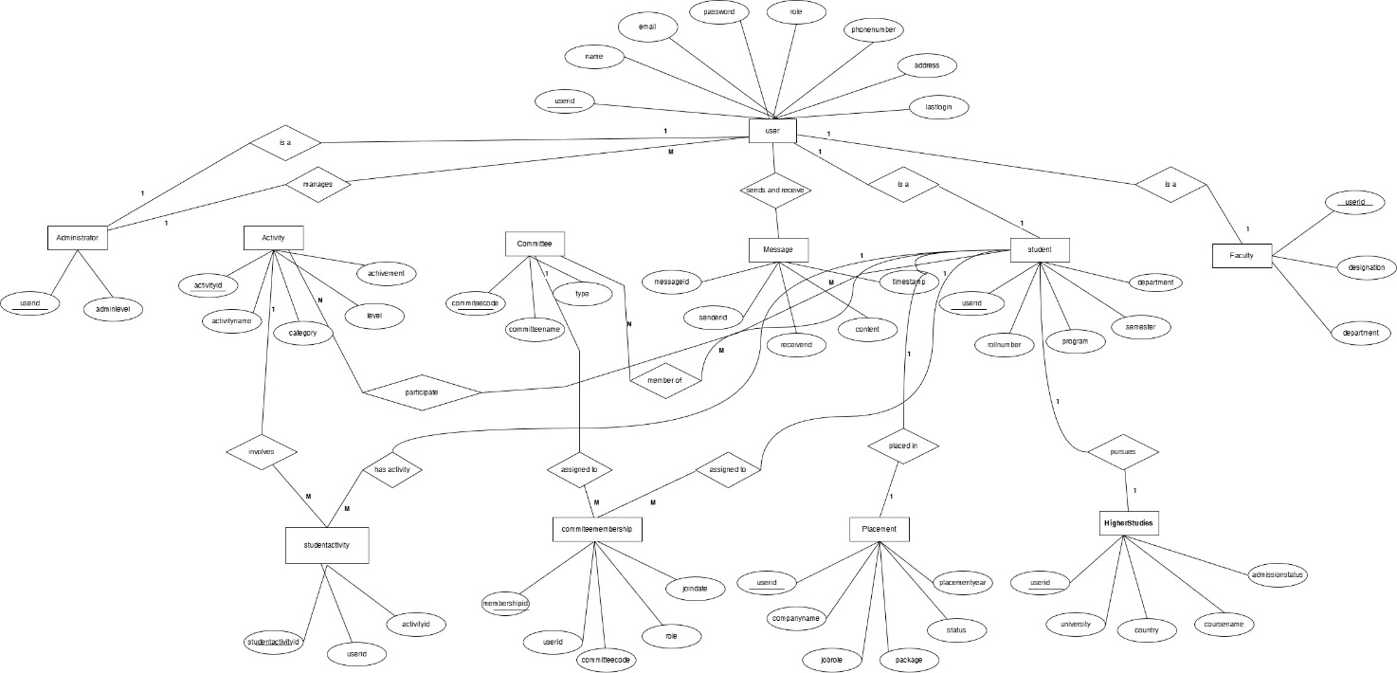
Normalization:
1. USER (Strong Entity)
Original Attributes:
userId, name, email, password, role, phoneNumber, address, lastLogin
Normalized Form:
userId (PK), name, email, password, role, phoneNumber, address, lastLogin
Normalization Steps:
- 1NF: All attributes atomic, unique rows.
- 2NF: Single PK (userId), no partial dependency.
- 3NF: No transitive dependency; all attributes depend only on userId.
2. STUDENT (Specialization of User)
Original Attributes:
studentId, rollNumber, program, semester, department, mobileNumber, address
Normalized Form:
userId (PK, FK), rollNumber, program, semester, department
Normalization Steps:
- 1NF: All attributes atomic. Removed mobileNumber and address (already in User).
- 2NF: Single PK (userId); all attributes fully depend on PK.
- 3NF: No transitive dependency; all attributes depend only on PK.
Notes:
- Placement and HigherStudies created as separate dependent entities (1:1 relation) to satisfy 3NF.

3. FACULTY (Specialization of User)
Original Attributes:
facultyId, name, designation, department, email, password, role, phoneNumber
Normalized Form:
userId (PK, FK), designation, department
Normalization Steps:
- 1NF: Atomic attributes; removed duplicates (name, email, password, role, phoneNumber) inherited from User.
- 2NF: Single PK (userId), all attributes fully depend on PK.
- 3NF: No transitive dependencies.
4. ADMIN (Specialization of User)
Original Attributes:
adminId, name, email, password, role, adminLevel
Normalized Form:
userId (PK, FK), adminLevel
Normalization Steps:
- 1NF: Atomic attributes; removed redundant attributes from User.
- 2NF: Single PK (userId), all attributes fully depend on PK.
- 3NF: No transitive dependency.
5. PLACEMENT (Dependent Entity of Student)
Original Attributes:
placementId, companyName, jobRole, package, status, placementYear
Normalized Form:
userId (PK, FK), companyName, jobRole, package, status, placementYear
Normalization Steps:
- 1NF: Atomic values.
- 2NF: Single PK (userId), attributes fully depend on PK.
- 3NF: No transitive dependency; placementId removed because 1 student → 1 placement.

6. HIGHERSTUDIES (Dependent Entity of Student)
Original Attributes:
studyId, university, country, courseName, admissionStatus
Normalized Form:
userId (PK, FK), university, country, courseName, admissionStatus
Normalization Steps:
- 1NF: Atomic values.
- 2NF: Single PK (userId), attributes fully depend on PK.
- 3NF: No transitive dependency; studyId removed because 1 student → 1 higher studies record.

7.Activity
Original Attributes:
activityId, activityName, category, level, achievement
Normalized Form:
activityId (PK), activityName, category, level, achievement
Normalization Steps:
- 1NF: Atomic attributes.
- 2NF: Single PK (activityId), attributes fully depend on PK.
- 3NF: No transitive dependencies.
Notes:
- StudentActivity junction table created to manage many-to-many relation with Student.

8. STUDENTACTIVITY (Junction Entity)
Original Attributes:
studentActivityId, userId, activityId
Normalized Form:
studentActivityId (PK), userId (FK), activityId (FK)
Normalization Steps:
- 1NF: Atomic values.
- 2NF: Single PK (studentActivityId), attributes fully depend on PK.
- 3NF: No transitive dependency.
Notes: Created to handle many-to-many Student ↔ Activity relationship.

9. COMMITTEE (Core Entity)
Original Attributes:
committeeId, committeeName, type
Normalized Form:
committeeCode (PK), committeeName, type
Normalization Steps:
- 1NF: Atomic attributes.
- 2NF: Single PK, attributes fully depend on PK.
- 3NF: No transitive dependency.
Notes: committeeCode auto-generated; avoids manual ID assignment.

10. COMMITTEEMEMBERSHIP (Junction Entity)
Original Attributes:
membershipId, role, joinDate
Normalized Form:
membershipId (PK), userId (FK), committeeCode (FK), role, joinDate
Normalization Steps:
- 1NF: Atomic values.
- 2NF: PK membershipId ensures full dependency.
- 3NF: No transitive dependency.
Notes: Handles many-to-many Student ↔ Committee relationship.

11. MESSAGE (Dependent Entity)
Original Attributes:
messageId, content, timestamp
Normalized Form:
messageId (PK), senderId (FK), receiverId (FK), content, timestamp
Normalization Steps:
- 1NF: Atomic values.
- 2NF: Single PK (messageId), attributes fully depend on PK.
- 3NF: No transitive dependency.

6.2 Use case diagram:
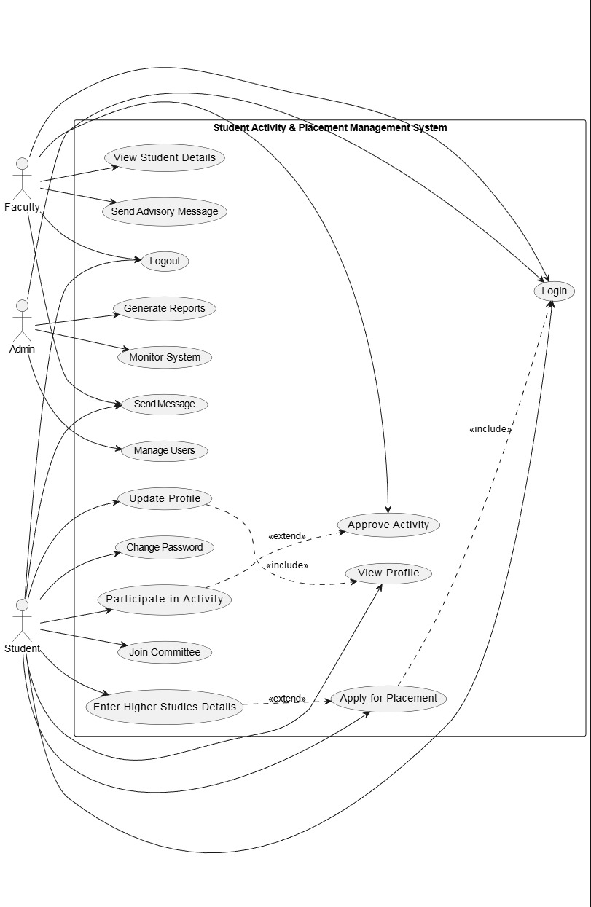

6.3 class diagram:

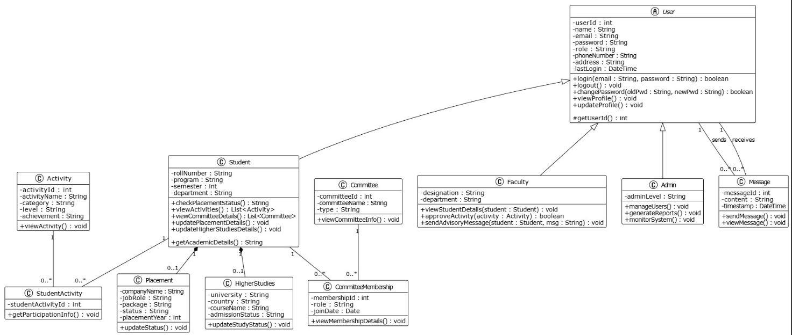

User (Abstract Class)
Description:
Base class for all system users. Stores common attributes to avoid redundancy.
Attributes:
- userId : int
- name : String
- email : String
- password : String
- role : String
- phoneNumber : String
- address : String
- lastLogin : DateTime
Methods:
- login()
- logout()
- changePassword()
- viewProfile()
- updateProfile()

Student (extends User)
Description:
Represents a student user in the system.
Attributes:
- rollNumber : String
- program : String
- semester : int
- department : String
Methods:
- checkPlacementStatus()
- viewActivities()
- viewCommitteeDetails()
- updatePlacementDetails()
- updateHigherStudiesDetails()

Faculty (extends User)
Description:
Represents faculty members.
Attributes:
- designation : String
- department : String
Methods:
- sendAdvisoryMessage()
- viewStudentDetails()
- approveActivity()

Admin (extends User)
Description:
System administrator with higher privileges.
Attributes:
- adminLevel : String
Methods:
- manageUsers()
- generateReports()
- monitorSystem()

Activity
Description:
Represents extracurricular or academic activities.
Attributes:
- activityId : int
- activityName : String
- category : String
- level : String
- achievement : String
Methods:
- viewActivity()
- updateActivity()

StudentActivity (Junction Class)
Description:
Represents participation of students in activities (M:N relationship).
Attributes:
- studentActivityId : int
- userId : int
- activityId : int

Committee
Description:
Represents institutional committees.
Attributes:
- committeeId : int
- committeeName : String
- type : String
Methods:
- viewCommitteeInfo()

CommitteeMembership
Description:
Represents student membership in committees.
Attributes:
- membershipId : int
- userId : int
- committeeId : int
- role : String
- joinDate : Date

Placement
Description:
Stores placement details of students.s
Attributes:
- companyName : String
- jobRole : String
- package : String
- status : String
- placementYear : int
Methods:
- updateStatus()
- viewPlacementDetails()

HigherStudies
Description:
Stores higher studies information of students.
Attributes:
- university : String
- country : String
- courseName : String
- admissionStatus : String
Methods:
- updateStudyStatus()
- viewStudyDetails()

Message
Description:
Represents messages exchanged between users.
Attributes:
- messageId : int
- senderId : int
- receiverId : int
- content : String
- timestamp : DateTime
Methods:
- sendMessage()
- viewMessage()

6.4 sequence diagram:
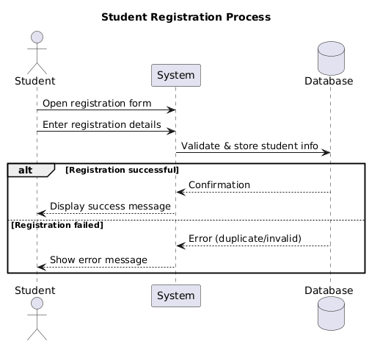
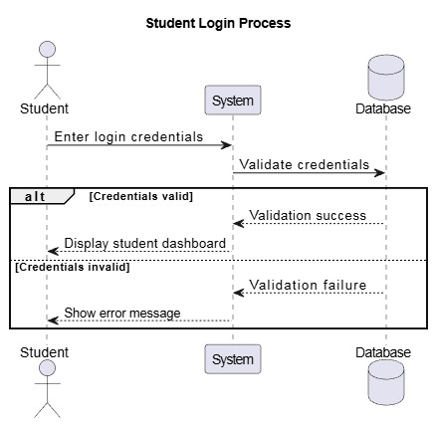
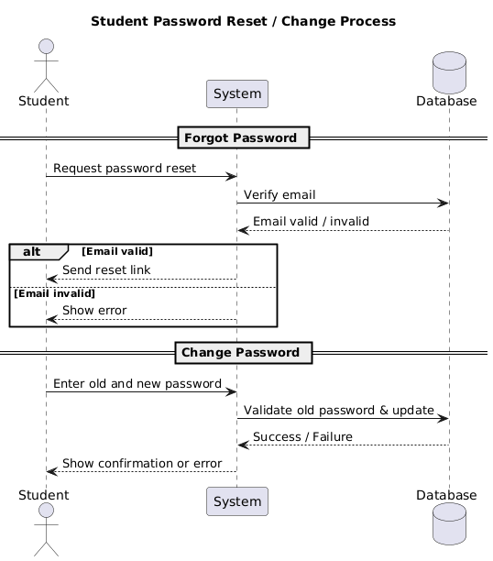
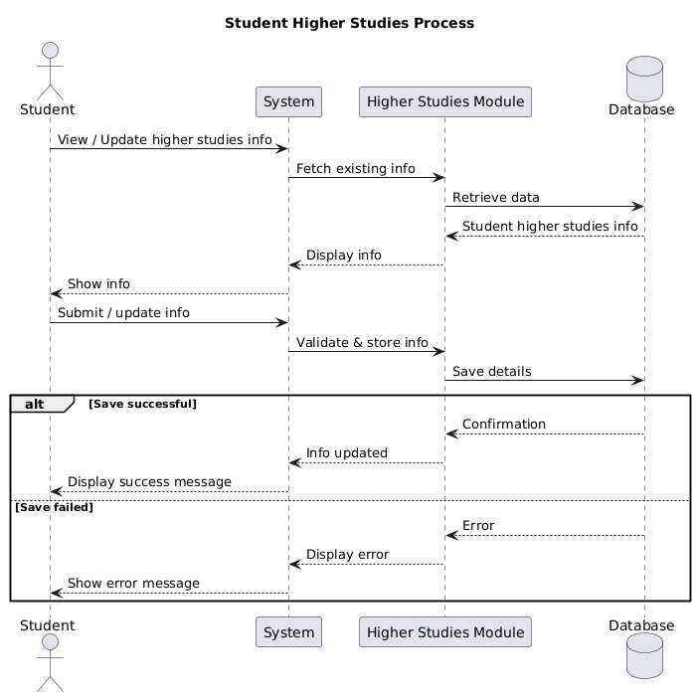

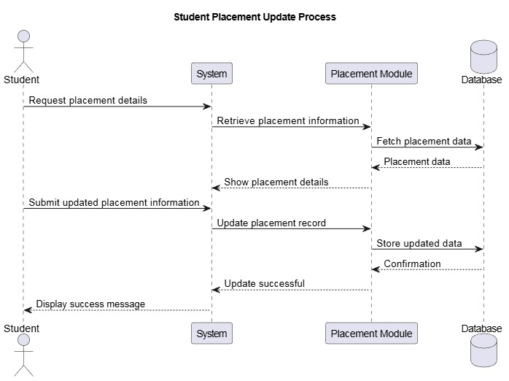
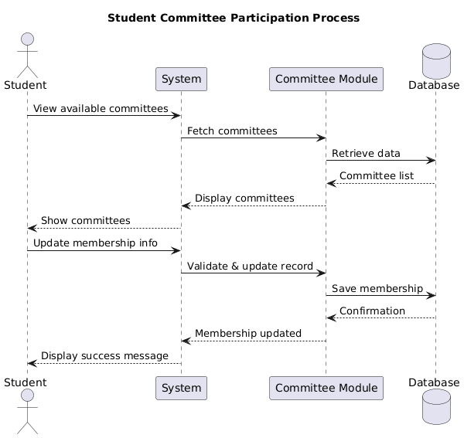

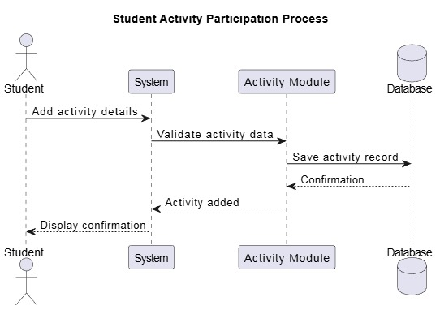

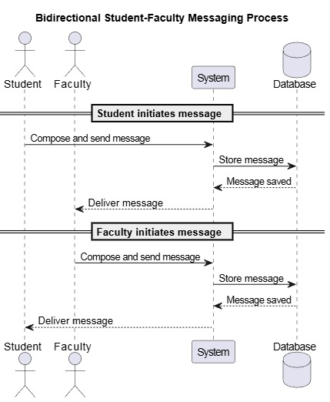
FACULTY SEQUENCE DIAGRAMS :
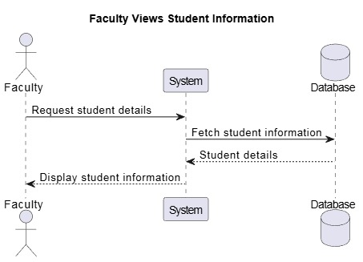

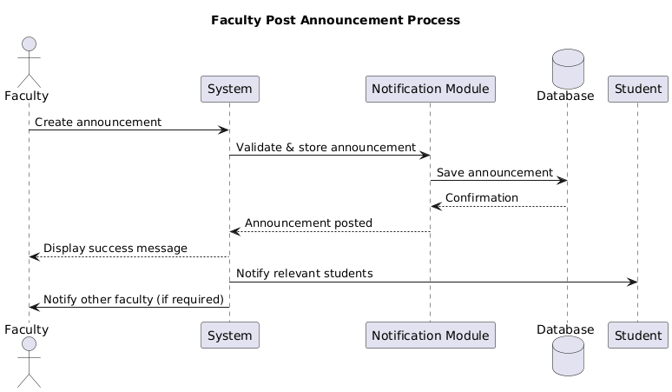

ADMINISTRATOR SEQUENCE DIAGRAMS :
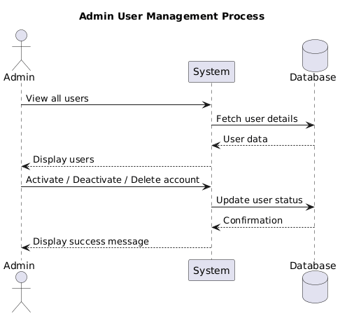

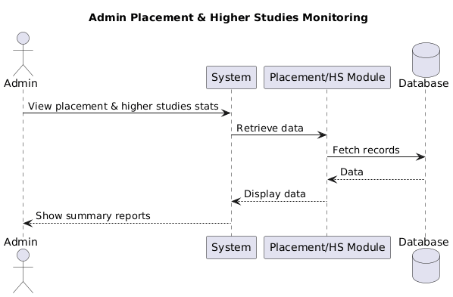
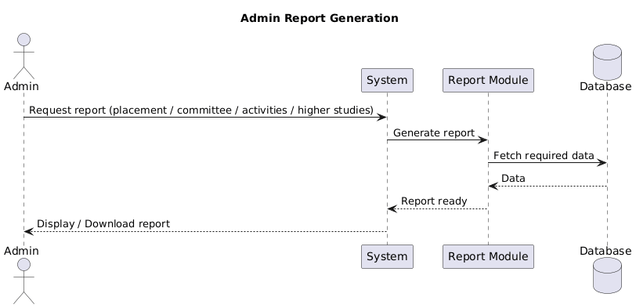

6.5 Data flow diagram:

DFD level 0:
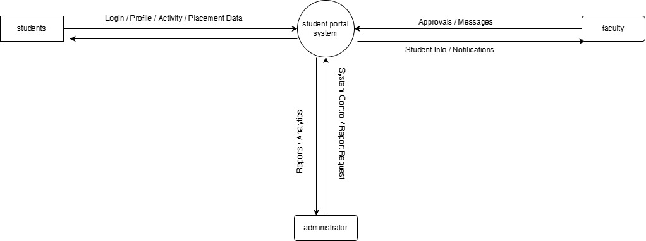

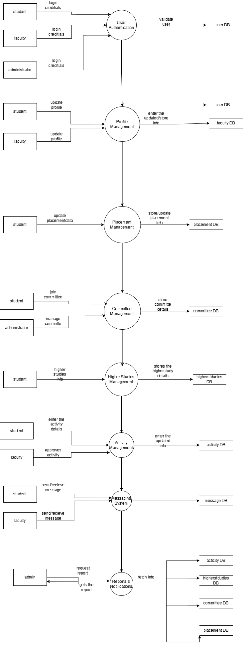

layer | technology | justification | References
Fronend : | HTML, CSS, JAVASCRIPT,BOOTSTRAP | HTML , CSS , and JAVASCRIPT are the standard web technologies that are compatible with the any browser . bootstrap provides the responsive interface which allow the accessibility in the different devices. | [1]
backend | PYTHON FLASK | Flask is the lightweight python framework that allows flexible development. As because of its simplicity it provides the better understanding of the backend architecture.  Can scale horizontally using Gunicorn and load balancing | [2] , [3]
database | MYSQL | MYSQL database ensures database integrity and efficient query handling.  Scales vertically and horizontally via replication and indexing | [5]
server | Gunicorn + Nginx | Gunicorn is WSGI server used for the execution of flask application  he Nginx is high performance web server used as a reverse proxy server and can able to handle large traffic. | [4]

References:
[1] Shelke, Kunal & Khan, Yusuf & Kapse, Dr. (2025). Student Management System: A Web-Based Solution for Academic Administration. International Journal of Scientific Research in Science and Technology. 12. 50-54. 10.32628/IJSRST251222719.

[2]Chauhan, N., Singh, M., Verma, A., Parasher, A., & Budhiraja, G. (2019).
Implementation of database using python flask framework: college database management system.
International Journal of Engineering and Computer Science, 8(12), 24894–24899. https://doi.org/10.18535/ijecs/v8i12.4390 :contentReference[oaicite:1]{index=1}

[3] Larasati, Sarah & Susetyo, Yeremia. (2024). Development of a Web-Based Trading Term Application Using Flask Framework at PT. XYZ. International Journal Software Engineering and Computer Science (IJSECS). 4. 367-376. 10.35870/ijsecs.v4i1.2339.

[4] N. Kataria, “Improving Service Reliability in Python uWSGI Stacks via Proactive 500 Error Handling,”
International Journal of Core Engineering & Management, vol. 8, no. 02, pp. 80–88, 2025.

[5] Subbiah, K. V., Dinesh, D., & Suresh, C. (2016). Development of a student database management system for a university. Int. Journal of Engineering Research and Application, 6(8), 16-24.

